2026 LJSS MOCK PROVISIONAL MARKING KEY
PHYSICS THEORY
PAPER 1
- a. Define the term electromagnetic wave.
- a transverse wave that is propagated in space or matter by oscillation of electric and magnetic field at a right angle to each other^{. 1}
b. Describe the relationship between the frequency, wavelength and energy produced by electromagnetic waves.
- The higher the frequency, the shorter the wave length¹ and the higher the energy produced by electromagnetic waves^{. 1}
or
- The lower the frequency the longer the wavelength ¹and the lower the energy produced by electromagnetic waves. ¹
c. Figure 1 shows dots made on a ticker tape pulled by a trolley through a ticker timer.
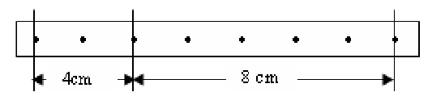
Figure 1.
Describe the motion of the trolley if the frequency is 50Hz.
- In the first 0.04 s, the body was traveling with a speed of 100 cms⁻¹ ⁽¹⁾and then the body decelerated and the speed reduced to 80 cms⁻¹ in the next 0.1 s. ⁽¹⁾
- a. Explain two properties of liquid pressure
- It acts in all the direction¹. The liquid molecules exert force which act at right angles to the wall of the container¹
- It does not depend on the shape of the container¹. Whatever the shape, the pressure at a given depth is the same¹
- It increases with depth¹. The deeper into the liquid, the greater the weight and the higher the pressure¹
- It increases with density¹ because denser liquid is heavier or has a greater weight than a less dense liquid of the same volume¹.
(Any 2 answers)
b. Explain how heating silicon enable it to conduct electricity
- By providing valance electrons enough thermal energy that breaks covalent bonds¹, freeing electrons from valence band to move to the conduction band¹. This process creates electron- hole pairs which acts as a charge carriers allowing current to flow¹.
c. Briefly explain how a piece of iron can be magnetized by stroking
- The magnetic material is stroked from end to end about 20 times in the same direction by the same polarity of a permanent magnet. 1
- Magnetism is induced in the object from the magnetic field of the magnet. 1
- The pole produced at the end of the magnetic material where the stroke ends is of opposite kind to that of the stroking pole. 1
- a. Define the internal resistance of the cell
- The resistance a cell offers to the flow of charges inside it. /1
- A battery of e.m.f 7.3 V and internal resistance of 0.3 ohms is connected in series with a resistor of resistance 9.5 ohms. Determine
- The current in the circuit
$$I=\frac{ε}{R+r}$$
$I=\frac{7.3}{9.5+0.3}$ 1
$I=0.745A$ 1
- Lost volts from the battery

$Lost volts=I×r=0.745×0.3=0.21V$ 1
- Explain how constructive wave interference occurs
- It occurs when travelling waves which are in phase meet ¹ to produce a wave of larger amplitude. ¹
- Figure 2 is a diagram showing a permanent of bar magnet being moved towards a coil. Use it to answer the questions
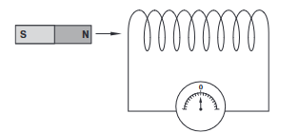

Figure 2
- (i) As current is being induced in the coil, what type of polarity is formed at end Y of the Coil?
- North pole /1
- Explain how to determine the direction of the induced current in a coil, when a magnet moves into the coil
- Applying Lenz’s law and right hand grip rule, the coil generates a magnetic field opposing the magnet’s movement, creating a repelling pole¹ .With the right hand thumb pointing the north pole, fingers curling in the direction of current¹
- Explain why a gas bubble released at the bottom of the lake grows in size as it rises to the surface of the lake.
- This is because when the bubble is at the bottom of the lake, the total pressure exerted on it is the sum of pressure due to the water column and the atmospheric pressure. /1
- As the gas bubble rises, because of the decline in the depth, the pressure because of the water column declines.1
- the bubble grows in size because the pressure decreases /1
- a. A convex lens produces a real image of an object and the image is 3 times the size of the object. The distance between the object and the image is 80 cm. Calculate the focal length of the lens
$$m=\frac{v}{u}=3$$
$v=3u$……(i) and $u+v=80……$(ii) 1
$u+3u=80→4u=80→u=20cm$ 1
$Hence v=3u=60 cm$ 1
$\frac{1}{f}=\frac{1}{u}+\frac{1}{v}=\frac{1}{20}+\frac{1}{60}=\frac{3+1}{60}=\frac{1}{15}$ 1
$f=15cm$ 1
b. Explain how the length of an inclined plane affects its mechanical advantage
- Increasing the length of an inclined plane increases its mechanical advantage ¹ and reduces the effort required to lift the object to a specific height¹
c.Figure 3 shows a detector of radiation
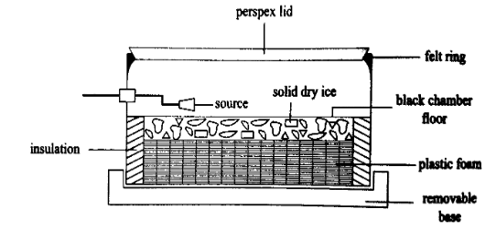
Figure 3
- Identify the instrument
- Cloud chamber /1
- How does the instrument work to measure presence of radiation?
- When a radioactive particle passes through air which is supersaturated with the vapor of a liquid, it produces ions that act as a centre on which the liquid can condense /1
- A line of liquid droplets is formed along the track of the particle /1
- The tracks of α- particles are straight and thick, the tracks of β-particle are thin and straight and the γ-rays do not produce tracks but they simply collide with electrons and give out enough /1
- a. Figure 4 shows a circuit with some electronic device in use.
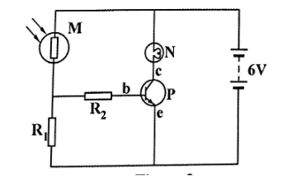
Figure 4
- Name the device M and P
M: Light dependent resistor /1
P: Transitor /1
Explain how part P operates as a light operated switch in the circuit during bright light
- In daytime, light shine on the photo-resistor, its resistance decreases¹ and more current flows in the base of the transistor^{1.} This current is enough to switch the transistor on and the bulb lights up¹.

- Calculate the height of a water column which exerts its base the pressure as 70 cm column of mercury. (Density of mercury is 13.6 g/cm³ and density of water is 1 g/cm³)
As the pressure of water and mercury is same,
$h_{w}ρ_{w}g=h_{m}ρ_{m}g$ ¹

$h_{w}×1=0.7m×13.6$ ¹

$h_{w}=9.52m$ ¹

- Construct a fixed resistor using resistor color codes with the value of 25 kΩ ± 10%

(1 marks)
b. (i) Explain briefly how water behaves as temperature decreases from 4ºC to 0°C
- it expands(its volume increases)¹ and becomes less dense¹
(ii) A body of mass 400g tied to string, is rotated in horizontal circle of radius 1.2m at 2 Hz. Calculate the tension developed in the string
$$F=mrw^{2} where w=2Πf$$
$F=0.4×1.2×(2Π×2)^{2}N$ 1
$F=7.68Π^{2} N$ 1
$F=75.8 N$ 1
- a. Figure 5 is a graph of force against extension.
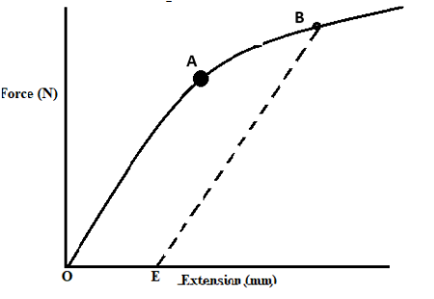
Figure 5
Describe the extension of the spring as illustrated from the graph
- The spring is said to undergo elastic deformation along OA.(OA obeys Hooke’s law)¹
- Point A is the elastic limit of the spring¹
- The spring is said to undergo plastic deformation along AB.(Hooke’s law is no longer obeyed beyond point A)¹
- Point B is the yield point (fracture point) of the spring¹
- OE is the permanent extension of the spring¹
Any 3 points
- A motorcycle and its rider have a mass of 500 kg. When moving on a level road at 20 m/s the rider disengages the gears, switches the engine off and come to rest after 50 m. Calculate :
- Retardation
$$v^{2}=u^{2}+2as$$
$0={20}^{2}+2×a×50$ (1)
$a=\frac{\frac{-400}{100}m}{s^{2}}=-4m/s^{2}$ (1)
- The average frictional force that stops the rolling motorcycle
$F=ma$
𝐹=500×4 (1)
$F=2000N$ (1)
- a. State the principle of conservation of mechanical energy
- The total mechanical energy (the sum of kinetic and potential energy) in an isolated system remains the same provided there are no external forces. ¹
b. A gas occupies a volume of 2 m³ when its pressure is 1140 mmHg and its temperature is 27°C. What volume would it occupy at standard temperature and pressure (0°C and 760mmHg)?

$$v_{2}=\frac{P_{1}×V_{1}×T_{2}}{P_{2}×T_{1}}$$
$v_{2}=\frac{1140mmHg×{2m}^{3}×\left(0+273\right)K}{760mmHg×\left(27+273\right)K}$ 1
$v_{2}=\frac{622,440}{228,000}$ 1
$v_{2}=2.73m^{3}$ 1
- Explain the mutual induction.
- When alternating current flows through the primary coil, alternating magnetic field is produced¹. This alternating magnetic field cuts the secondary coil¹. The cutting of alternating magnetic field on the secondary coil induces e.m.f in the secondary coil, which causes deflection on the pointer of a galvanometer¹
(ii). Explain how an echo can be used to determined the depth of the sea
- Sonar determines sea depth by emitting sound pulses from a ship¹ and measuring the time it takes for the echo to return from the seabed¹ using the formula: ( depth =speed of sound*time/2) ¹
- a. Figure 6 is a diagram showing waves on a rope xy．
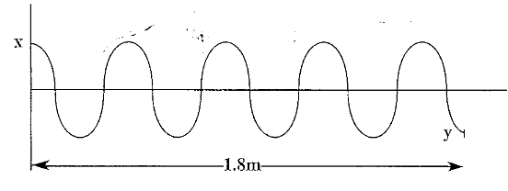
Figure 6
If the rope xy is swung up and down 20 times in 2 seconds, calculate the average speed of the wave.
$f=\frac{20}{2}=2Hz$ 1
$λ=\frac{1.8m}{4.5}=0.4m$ 1
$v=fλ=2×0.4=0.8m/s$ 1
  - Explain how a micrometer screw gauge can be used to measure the thickness of a paper.
- Place the object whose thickness is to be measured in between the jaws (the anvil and the spindle) of the micrometer. 1
- Rotate the ratchet clockwise until the jaws touch the object.1
- Get the sum of the two readings i.e. sleeve scale reading and the thimble scale reading 1

- In one particular experiment, the mass of the trolley was kept constant. The time t for the trolley to move a distance of 1.0 m from rest was determined for various values of the pulling force F. The acceleration a was calculated using the s=1/2at² where s=1.0 m. The following values were obtained.
Force applied (N) | 0.40 | 0.60 | 1.20 | 1.60 | 2.00
Acceleration (m/s²) | 0.06 | 0.22 | 0.43 | 0.57 | 0.74
Table 1
Plot a graph of force against acceleration
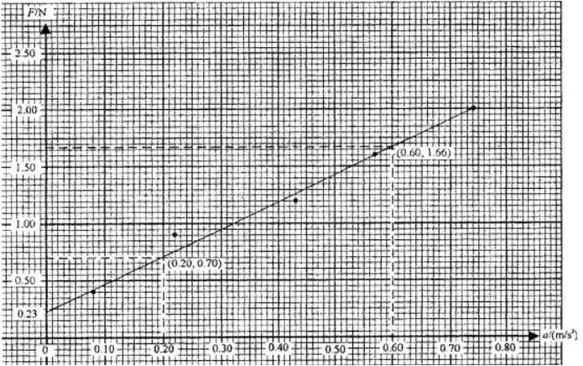
(3 marks)

Section B (30 marks)
Answer all the three questions in this section in the spaces provided.
- a. Figure 7 is a diagram of alternating current () generator
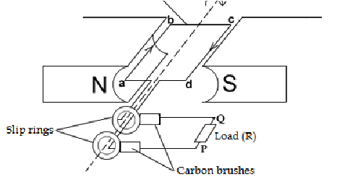
Figure 7

Explain how an alternating current (a. c) generator works
  - When the coil abcd is rotated in the magnetic field in the clockwise direction i.e ab moving upwards and cd moving downwards, the sides cut through the magnetic flux and current is induced in them.
  - By Fleming’s right hand rule, the induced current through side ab flows from a to b while that through side cd is from c to d.
  - The induced current is tapped from the coil through two carbon brushes which press tightly on the slip rings
  - After turning through 180⁰, side ab now moves downwards while side cd moves upwards. This
means that by Fleming’s right hand rule the direction of flow of the induced current through side ab is from b to a while that through side cd is from d to c. i.e the current is reversed
(5 marks)
b. With the aid of labeled diagram describe how the mass of an object can be determined using the principle of moments.
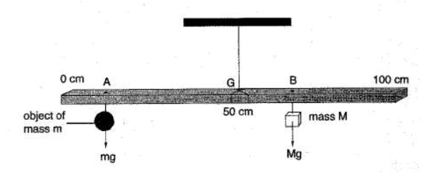/1
- Suspend a uniform meter rule at mid points G and the object of mass m from point A . /1
- Suspend a known mass M object on the other side of the meter rule and adjust the position of mass m till the meter rule is horizontal. /1
- Record the distances GA and GB. /1
- Calculate the mass of the object using the formula:
$$mg×GA=Mg×Gb$$
$m=\frac{M×GB}{GA}$ / 1
- a. Using a truth table, describe how a NAND gate works.

INPUTS |  | OUTPUTS
0 | 0 | 1
1 | 0 | 0
0 | 1 | 0
1 | 1 | 0
1/1/1/1
- The output is ON if inputs A and input B are not both ON or both inputs 0. The outputs are a reverse for all combination of AND gate./1

b. Explain how p-type semiconductor can be produced using the doping method.
- It is produced by adding impure atom (i.e boron which has 3 electrons) that has fewer electrons in the valence band. ¹
- This leaves the material with a deficit of electron on the boron hence creating a hole. ¹
- When an electron jump into the hole, hole moves in the opposite direction ¹ hence the flow of current. ¹
- Since the material has more holes than electrons , the semiconductor is known as p-type ¹
13. a. With the aid of a labeled diagram, describe the problem of short sight in human eye
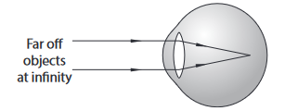/1
- A short sighted person can see near objects clearly but not distant objects. /1
- The image from a distant object is formed in front of retina./ 1
- This defect arises due to the eyeball being too long or more refraction take place at cornea /1
- hence the focal length of the eye lens becomes short /1
b. With the aid of a well labeled diagram, describe the refraction of water wave as they travel from shallow to deep region

- the frequency remains the same ¹
- The wavelength increases due to increase in speed ¹
- The wave appears to change the direction due to the change in speed ¹

